6th grade Science Syllabus

Mrs. Emily Medlin

NWMS

[medline@gcsnc.com](mailto:medline@gcsnc.com)

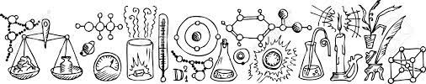

Welcome to 6th grade science!!! This year we will engage in a lot of hands-on, effective, and engaging science lessons. I can’t wait for an awesome year of exploration, discovery, and growth!

Materials

The following materials are needed every day for class, unless otherwise instructed. Please only have your child carry the necessary materials to avoid heavy bookbags.

* Charged Chromebook (we will use an online digital notebook)
* Notebook paper
* Pencils
* Headphones ***\*Please ensure your child has their own headphones they can use. Please also make sure they are WIRED. NO BLUETOOTH/AIR PODS. \****

Grading Policy

|  |  |
| --- | --- |
| Tests and Projects | 45% |
| Quizzes | 20% |
| Classwork | 35% |

6th grade Science Units –

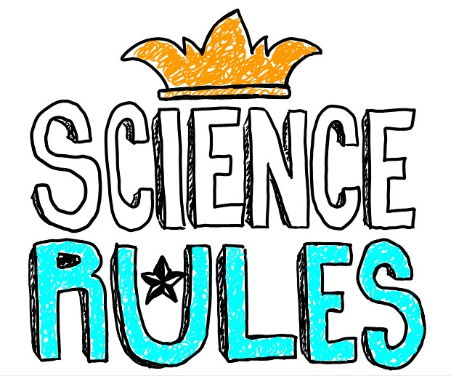

Unit 1 – Matter, Properties, and Change

Unit 2 – Energy: Conservation and Transfer

Unit 3 – Energy: Properties of Waves

Unit 4 – Earth Systems, Structures, and Processes

Unit 5 – Structure and Function of Living Organisms

Unit 6 – Ecosystems

Unit 7 – Earth’s Place in the Solar System

**Important Things to Note -**

* **Absences –** If you know your child will be absent from school, please communicate that with me via email or Remind messages. Course content and classwork will be uploaded to Canvas daily, so it’s important that even when your child is absent, they still check Canvas to see what they missed. If you plan a trip, and your child will be absent for more than one day, please communicate that with me so I can ensure you have any necessary materials and course work.
* **PowerSchool** is the **OFFICIAL** grades for your child. These are the grades on your child’s progress report and report card. The grades from Canvas and other assignments will all be entered in PowerSchool where it will calculate their actual grade in the course. Please make sure you have access to your child’s grades and check them periodically throughout the year.
* **Grading Policy -** According to GCS Board Policy, “students are responsible for all work missed when absent from school. Immediately upon returning to school, students must make arrangements with their teacher(s) to make up all work (assignments, tests, projects, etc.) missed while absent”. All make-up work including tests and quizzes must be completed or arrangements made within three school days of returning to school.​
* ***Students are expected to use Canvas to stay up to date with current assignments while they are absent from school. \*\*\****
* As teachers, our job is to partner with parents in preparing students for 21st century skills, meeting expectations and due dates, setting personal goals, and taking pride and accountability in their work and for their actions. ​
* Therefore, according to our school handbook, teachers will not accept grades/work for any student who is consistently present in school but fails to turn in class assignments/homework on time. This will result in a "0/100" and cannot be submitted later for a grade. Consistency and accountability are key! Please support us in this matter. ​
* Students who receive specialized instruction or modifications are the exception.
* Please do not hesitate to reach out regarding any questions or concerns you may have. You can reach me either via email or Remind messages.
  + Email: [medline@gcsnc.com](mailto:medline@gcsnc.com)
  + Remind: Join by texting 81010 this message - @2425med